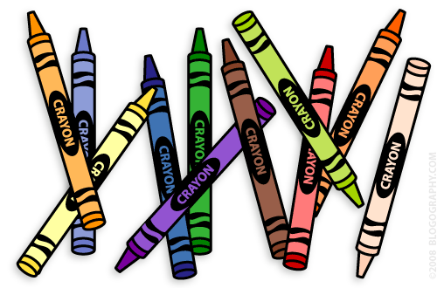
Our 1st Grade Classroom News
The Week of August 21st – 25th

Email: Lweeks@bluevalleyk12.org
Website: https://teachers.bluevalleyk12.org/Domain/559

- At least ONE challenge of the week is due every Friday. Students will be bringing home a homework notebook that they can complete them in today (Friday). They do not have to bring that notebook back to school until it is due the following Friday. Students are not used to writing in notebooks yet, so as long as they complete one with a date at the top, it should be good to go! I am not picky about this!

- Our administration would like us to reiterate that when the rule says ‘no birthday treats’, that means no edible and non-edible treats (little toys). We will do an extra recess and allow them to be line leader instead.

Important Info

Sept. 4th NO SCHOOL

Upcoming Events
Website of the Week – www.funbrain.com is always a fun website for students. It has games for math and reading and most are right on 1st grade level. We will use this website at least a couple times this school year.
App of the Week - Make Dice - Create math dice for your student to practice their math facts! You can make any kind of dice using this app!

Math Challenge of the Week - We have been working on finding 2 numbers that equal another number. Give your child some numbers anywhere between 4 and 15 and see if they can come up with 2 numbers that make it. For example, if you pick the number 11, they may say 6 and 5 make 11 (6+5=11). To enrich your child more, give them a higher number that you think they can find what numbers make it.
Reading Challenge of the Week - Read a fiction book together and make connections with it (text-to-self connection)! How can the book relate to things that have happened in your life? You can have your child write about their text-to-self connection or you can write down what they say. For example, they might read about a boy who plays soccer and your child plays soccer too. If you want to enrich your child more, have them come up with a text-to-self and text-to-text (making a connection with another book) connection.
Writing Challenge of the Week - Make a list of topics with your child on what they can write about at home. Have them write this list of topics (at least 5 topics) in their notebooks so I can see what kind of things they like to write about! For example, a topic they might pick might be ‘recess’.

Challenges of the Week
Tech of the Week

